InsureEasy – Insurance Management
Project: InsureEasy | Technology: HTML, CSS, JavaScript (localStorage)

Aim
To develop an insurance management system for admin, agents and customers covering policies, premium due alerts, payments and claims.

Algorithm
- Start: load users, policies, claims and SMS log.
- Agent registers; admin approves or rejects the agent.
- Agent adds customers and policies with due dates; can edit or delete.
- System checks due dates and sends SMS alerts (alertDue) to customers.
- Customer pays premium and files a claim.
- Admin/agent reviews claims; status updated.
- Save data. Stop.

Result
The InsureEasy – Insurance Management was implemented successfully using HTML, CSS and JavaScript. All modules (login, role-based pages, data entry, search/booking and admin management) work correctly in the browser, and data persists using localStorage.

Implementation (Output Screenshots)
Home page
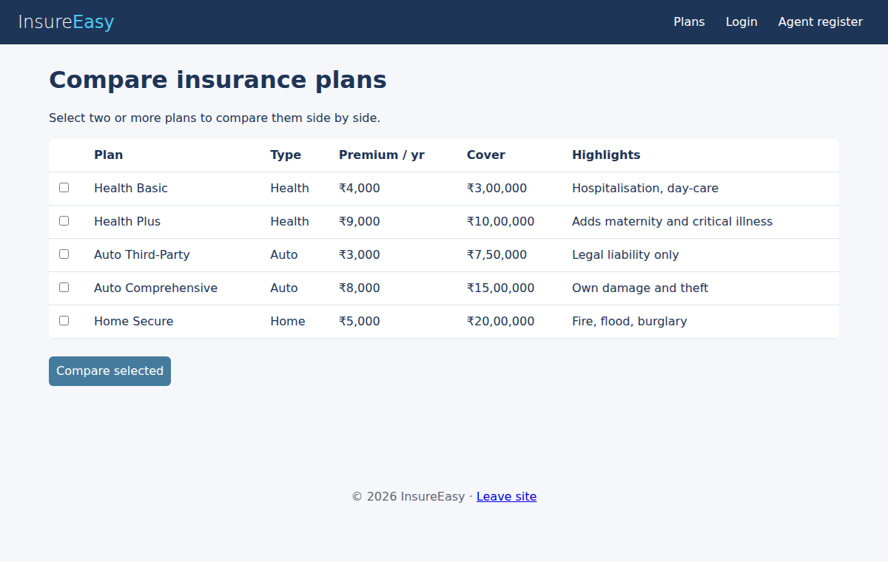
After login (admin / dashboard)
